Parish Council

**SADDLEWORTH**

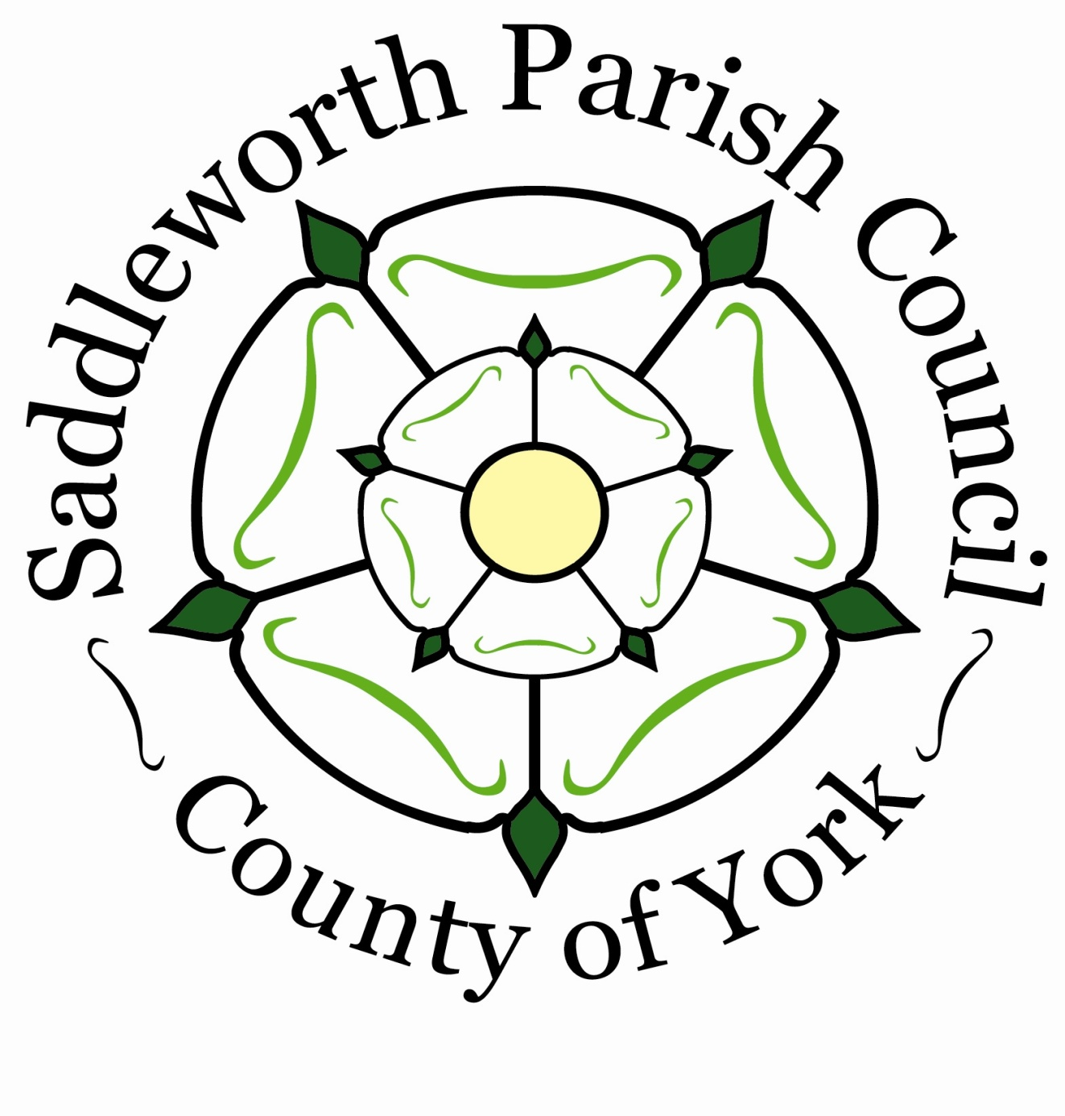

Notice is hereby given that the

**ANNUAL PARISH MEETING**

will be held on Monday 19th May 2025 at 6.30pm

at the Civic Hall, Lee Street, Uppermill

**All ELECTORS** of Saddleworth Parish are entitled to attend

and take part in the meeting.

**Chaired by Cllr. Barbara Beeley Chairman**

The Parish Meeting may, by law, discuss all Parish affairs and pass resolutions about them.

Signed: **Cllr. Barbara Beeley** Date: 9th May 2025

**…………………………………**

Cllr. Barbara Beeley, Chairman

**Agenda:**

1, To share the Annual Report for 2024/25 from the Parish Council.

2, To receive questions

3, Date of next meeting 18th May 2026.

Working for Saddleworth

Karen Allott, Clerk to the Council

Council Offices, Civic Hall, Lee Street, Uppermill, Saddleworth OL3 6AE

Tel: 01457 876665

**e-mail:** [**enquiries@saddleworthparishcouncil.org.uk**](mailto:enquiries@saddleworthparishcouncil.org.uk)[**www.saddleworthparishcouncil.org.uk**](http://www.saddleworthparishcouncil.org.uk)